User Guide

Glucose Follower

# Getting Started

* 1. First Start

The first time turning on the device it will look like this

You will be asked to sign onto a wifi access point called Glucose Follower

Find this on your smartphone and connect.

* 1. Signing on

After connecting you will be asked to sign in some info. Click the popup that comes and you will go to the following screen.

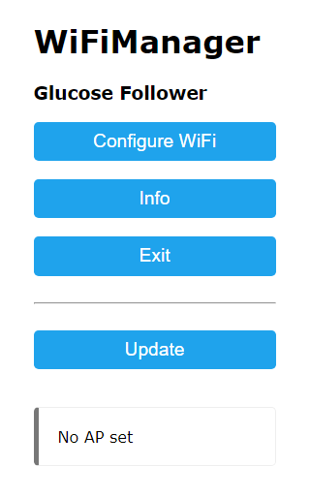

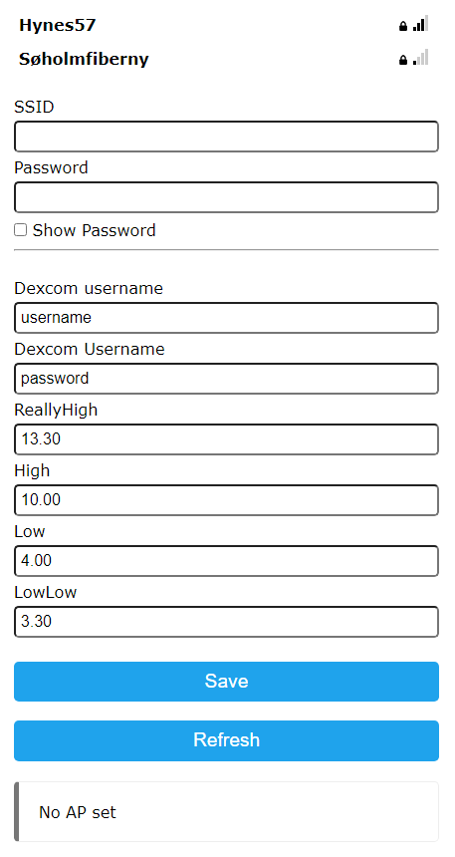

Click “configure wifi”

And after click your own wifi and fill in the password.

If you can’t see your wifi try to press the refresh button.

Next remember to fill out your Dexcom username and password.

We you are finished click “save”

Wait a minute and the lights will blink on the device and you will be brought to the main screen.

If this doesn't work then possibly something is filled out wrong and you need to connect to the wifi access point again and fill out your info and save.

* 1. Buttons

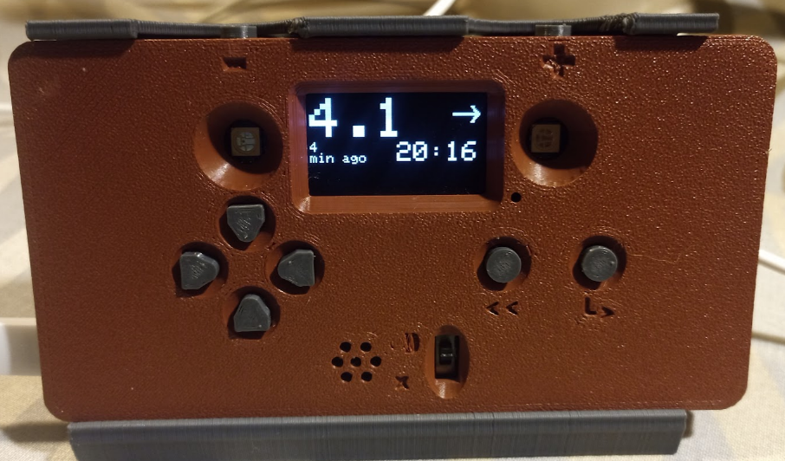

Snooze -

Snooze +

Select/enter

Back

Sound on/off overide

on

off

Up, Down, Left Right

USB Power

ON/OFF

* 1. Three main displays

There are 3 main displays Overview, graph and Alarm Settings. To navigate between them you can use the ‘**LEFT**’ and ‘**RIGHT**’ buttons.

**Overview Graph Alarm Settings**

**Overview**:

The overview screen shows:

* The current blood sugar
* The trend arrow
* How old the reading is
* The time of day.

The overview screen also shows the minutes alarms are snoozed. An snooze function for alarms is activated by the “+” button on the top of the device. It addes 5 minutes of snooze for every time pressed. And the “–“ button removes 5min until 0 is reached.

The snooze buttons can be used in any display mode or menu. But the amount of snooze time can only be viewed in the Overview screen.

**Graph**:

The graph display shows a rutamentry graph with vertical dotted lines marking the hour marks and 2 horizontal lines marking 4 mmol and 10 mmol.

The graph can be zoomed in and out on the time axis by pressing the “up” and “down” buttons while viewing this screen.

**Alarm Settings**:

In the alarm settings and up and down buttons can be used to highlight one of the 4 alarms.

There are 2 low alarms and 2 high alarms.

To see the specific alarm settings press the “select” button while it is highlighted.

**Alarm specific settings**:

The alarm specific settings can be navigated with the “up” and “down” arrows to highlight a specific setting. To return to the previous “alarm settings” screen you must press the “Back” button. To select a specific setting to change press the “select” button.

**Setting selected**:

When a setting is selected the “up” and “down” buttons can be used to scroll through the possible alternatives.

** To preview the sound and color press the “select” button while any setting is selected.

**Active**: This determines whether this alarm is active or not.

**Level**: This is the level that the alarm is set to (for the given high or low alarm)

**Continuous**: This can be set to “once” or “yes”

***Once***: The alarm activates the sound once for each new reading that is over/under the high/low alarm

***Yes***: The sound will be continuously looping until the snooze function is active or a “Normal” bloodsugar level is delivered.

**Blinking**: Determines whether the LED’s should Blink brightly or not blink (The still light up when not in blink mode).

**Sound**: Yes if you want sound. No if you want it to be a silent alarm.

**Melody**: Choose a Melody for the alarm tone. (press select to preview)

**Color**: Choose a color to indicate this specific alarm.

* 1. Sdf
  2. Sdf